90 years together in K-W

1926-2016

Слава Ісусу Христу! Слава на віки!
The Most Holy Trinity
ПРЕСВЯТА ТРІЙЦЯ
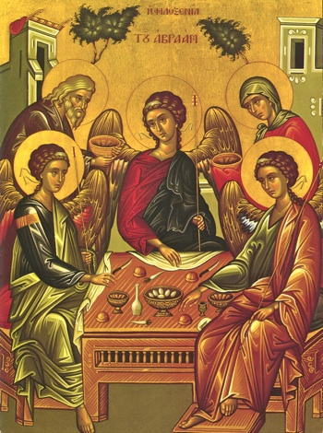
26.06.2016 & 3.07.2016
Glory to Jesus Сhrist! Glory Forever!
Friday 7:00 p.m. Вервиця /Rosary
We have seen the true light, we have received the Heavenly Spirit, we have found the true faith, we worship the undivided Trinity, for It has saved us.
Ми бачили світло Істинне, ми прийняли Духа небесного, ми знайшли віру істинну, нероздільній Тройці покланяємось, Вона бо спасла нас.

Прошу незабути записати ваші інтенції на молитви/Please leave your prayer intentions
CONGRATULATIONS
to Rozmaj dancers for their performance at the KW Multicultural Festival!!!
Щире спасибі всім жертводавцям.
June 19, 2016: Regular: $494. Papal charities: $10.
Thank you to all our kind donors!
Happy Birthday! Многая літа !
Вітаємо парафіян котрі цього тиждня відзначують день народження. Greetings and best wishes to all our parishioners who celebrate their birthday this week: Alina Trusz (6th), Adrian Kocan (9th).

TOGETHER WE HONOUR OUR PAST AND BUILD FOR THE FUTURE!

The Monday after Pentecost we celebrated the Feast of the Holy Trinity. “In the name of the Father, and the Son, and the Holy Spirit. Amen.” As Ukrainian Catholics, these words are among the very first we learn. The sign of the cross—used frequently and generously—is familiar, repeated in threes, with three fingers held together. We often repeat liturgical prayers 3 times as well. The number 3 signifies completeness and wholeness in many cultures throughout history but our focus on threes reinforces our understanding of God as 3 persons in 1 being. Like the early church communities, our Faith is based in the Trinity; we are Trinitarian. But what does being Trinitarian mean?
The idea of one person being 3 persons is baffling, to say the least, but the Trinity is the formulation of our human experience of God. At the same time, reflecting on the Trinity reveals God to us in a way that is extraordinarily engaging. The Father, Son, Holy Spirit not only provides the basis for the formation, existence, and meaning of Church but it can also richly inform our personal lives.
In our Faith Tradition we have icons (visual prayer) to help us contemplate the triune God. In iconography, we see the Trinity as the 3 weary travelers of the Genesis story (18:1f.), invited into Abraham and Sarah’s home to eat and rest. This icon of the Trinity is also known as the Hospitality Icon, because of the generosity of the couple towards strangers. The 3 strangers were later revealed as angels, heavenly beings, who in gratitude and thanks announced that a child would be born to the elderly couple, long past their childbearing age. Their invitation and generous welcome to “others” resulted in the lineage that would in time lead to Christ.
Father, Son and Holy Spirit—in the iconographic image—sit at a dining table eating. They are hungry, tired, in need of help. Could this be God? Needy? The figures of Abraham and Sarah join in a circle formed by the 3, separate but identical figures. The circle suggests a flow of movement that sweeps us, as the observers, into it. The need of the figures is served by the welcome of the hosts who are served by the gratitude and contentment of the guests. In the circle we are embraced into a flow of interdependence, where we support and serve each other, regardless of our neediness. This dependence on one another and the circle itself creates a wholeness, that paradoxically is in motion, always and continually sweeping in the stranger, who cannot remain a stranger in the embrace. This is the movement of Love—Divine Love—that is so giving, so overflowing that it must spill over to another. Hence God, as Love, cannot possibly be one person, since love in its essence must go beyond itself to others. This movement of love to another—to a stranger—moves through relationship. We grow in love from giving and receiving, and then, necessarily, through loving relationship we include others into this dynamic community. Finally, Trinity exemplifies community: the community that we, as Christians, can ceaselessly strive to create by a loving embrace of those in need.

Готуємося на приїзд Патріярха Святослава в четвер, 29-го вересня!
Джаймс Френч організує групу охочих в маленький хор щоби відспівати кілька пісень вчасі бенкету: зголосіться до нього james.andrew.french@hushmail.com або прийдіть в четвер, 7-го липня до залі під церквою на 7-у год. веч.

We’re starting to prepare for the visit of Patriarch Sviatoslav on Sept. 29th
If you, or anyone you know, wishes to sing in a Ukrainian folk choir for the 90th Anniversary celebrations, please talk to James French in church or contact him by email: james.andrew.french@hushmail.com.
The first practice will be in the church basement at 7:00 pm on Thursday, July 7th.
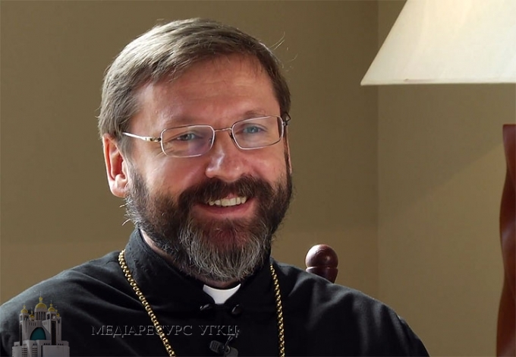
УВАГА! УВАГА! IMPORTANT INFORMATION!
Fr. Myroslaw will be away from June 27 until July 8.
Отець Мирослав виїзджає від 27-го червня до 8-го липня.
В разі наглої потреби прошу звернутися до о. Зеновія Багрія на число: 1-647-261-4509.
In the case of an emergency, please call Fr. Zenoviy Bahrij at 1-647-261-4509.

